**Assignment 3**

By-

Drishti Mamtani(20165A70574H)

Shreyansh Jain(2016B1A30947H)

Shreya Saxena(2016A4PS0367H)

Initially, a=2 and b=3 is assumed as the mean of the prior should be 0.4

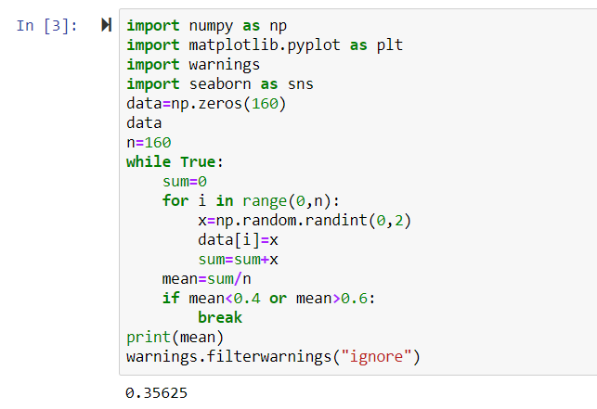

μML=0.35625

**Part A: Sequential Learning**

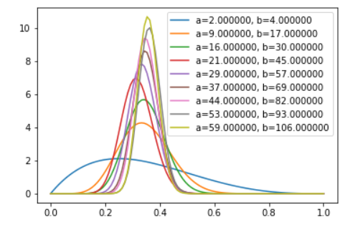

**X-axis- X values**

**Y-axis - Beta Distribution**

With each point, the values of a and b keep changing.

Finally, we get a Beta function with a=59 and b=106.

The movement can be seen via a GIF.

**Part B**

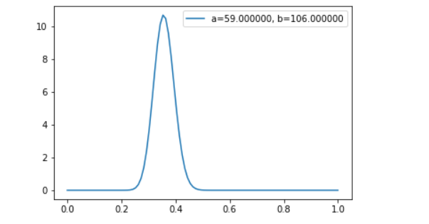

**X-axis- X values**

**Y-axis - Beta Distribution**

When all the data points are taken together then we get the posterior distribution to be a Beta function with parameters a=59 and b=106.

# **Part C**

The final plots are the same for both the models that are they give the same posterior beta distribution. The sequential model is preferred in case the dataset is too large or when a real-time steady stream of data is taken as input. Because they do not require the whole data set to be

stored or loaded into memory, sequential methods are used widely.

If more points are added ideally both the methods should give the same results but because sequential learning uses posterior function of one data point as prior function for the next data point hence it is more effective over the Beta model which might have an error term associated with it.

When μML=0.5 then change in a and b from prior distribution to final posterior distribution remains the is equal. That is a and b change equally. Also, the ratio of a/b which was equal to 0.4 now increases and becomes very close to 1.